So to finish off our project, we didn’t get done, but it wasn’t without a good effort. While my part may appear incomplete, it was because I wasn’t able to progress without other parts being done, which they weren’t. Here’s what happened…

1. We decided on JavaScript as the language for this project. Despite only 2 people knowing the language, that was the majority vote. The two people said they would help the others in understanding and coding the language.
2. We assign out workloads to each group member. I ended up with “Trends”, which involved creating and displaying graphs.
3. Fast-forward to when we decide on the language to write in, we vote between JavaScript and C#. JavaScript has really good tools for web development, but only 1 person in the group knows how to use it. C# isn’t as straightforward, but many of us know how to use it. I argue that we should use C# since it works and we wouldn’t have to learn Javascript closer to finals week and end up not knowing how to do that code.

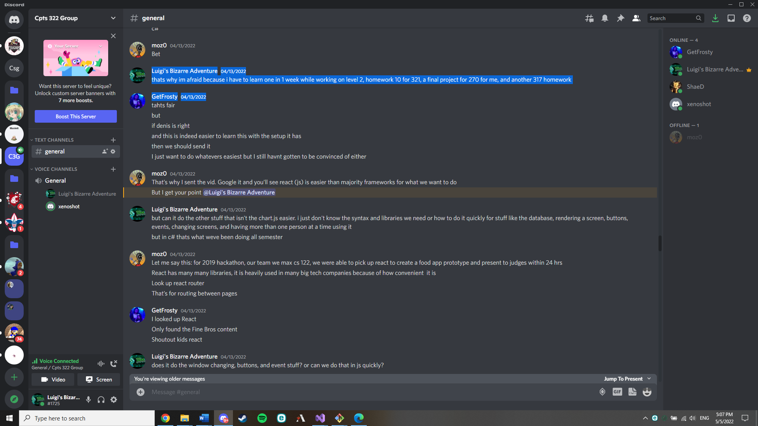

However, the majority decides on Javascript, so we begin working in Javascript with the person suggesting it saying that he understands he will be needed for a large portion of the project.

1. As progress begins, one of our teammates starts to understand it well since he’s worked in python a lot and it’s similar, but 3 members, including myself, are struggling to understand Javascript since it’s very different than any coding language we’ve done before. While this is going on, the person who said he would help us misses the mark multiple times for group meetings.

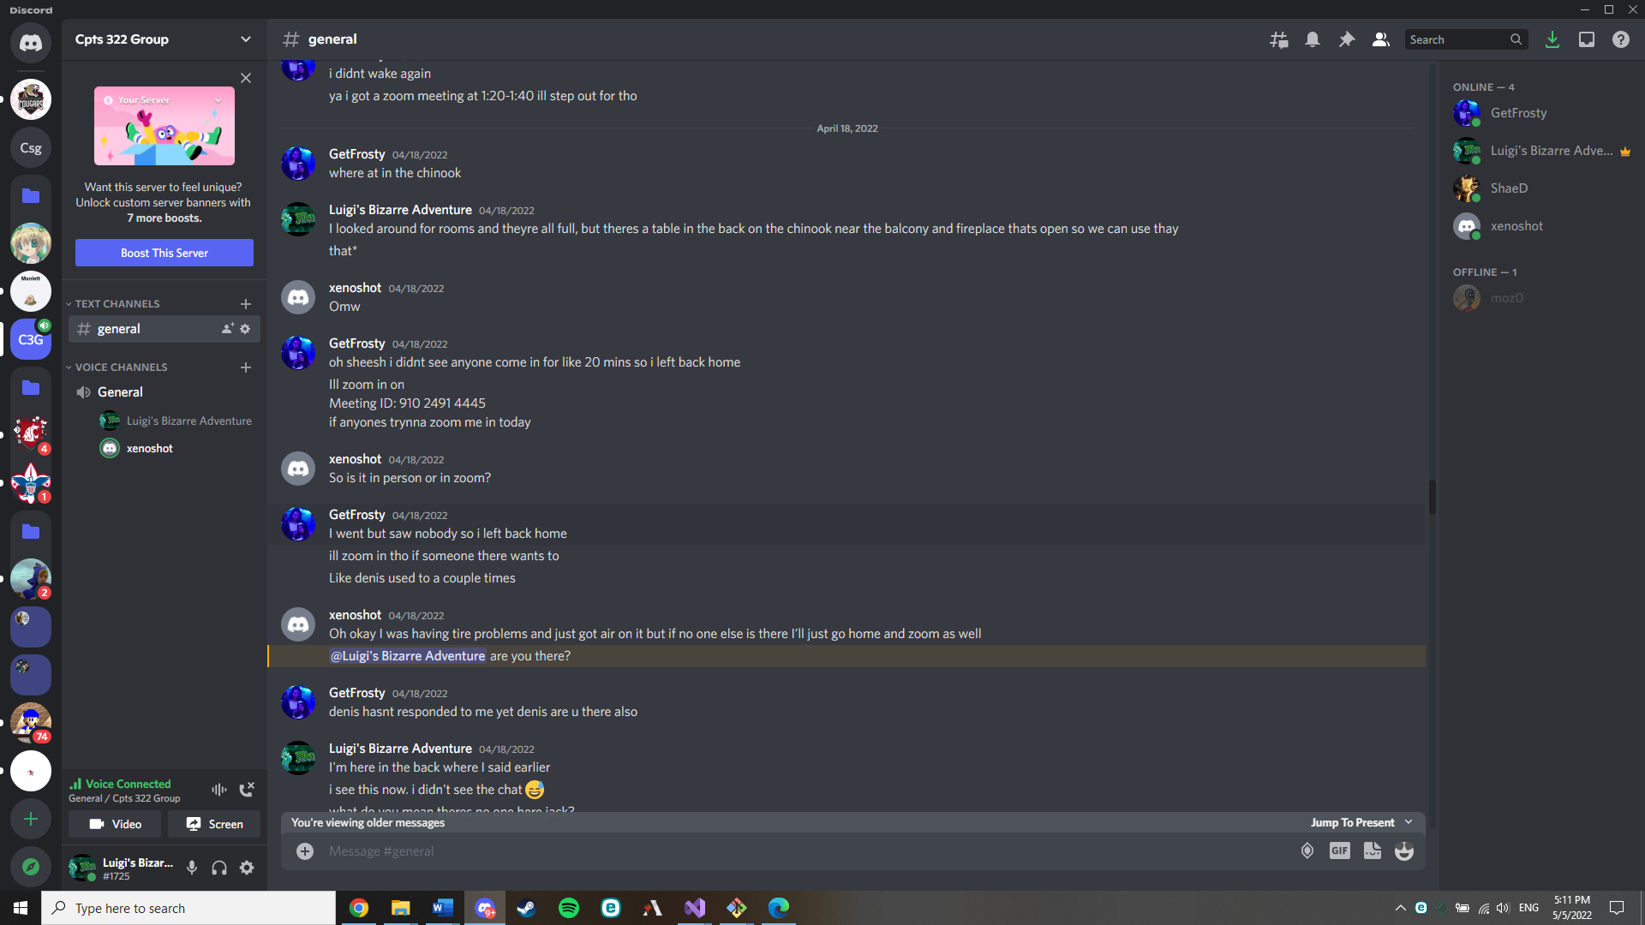

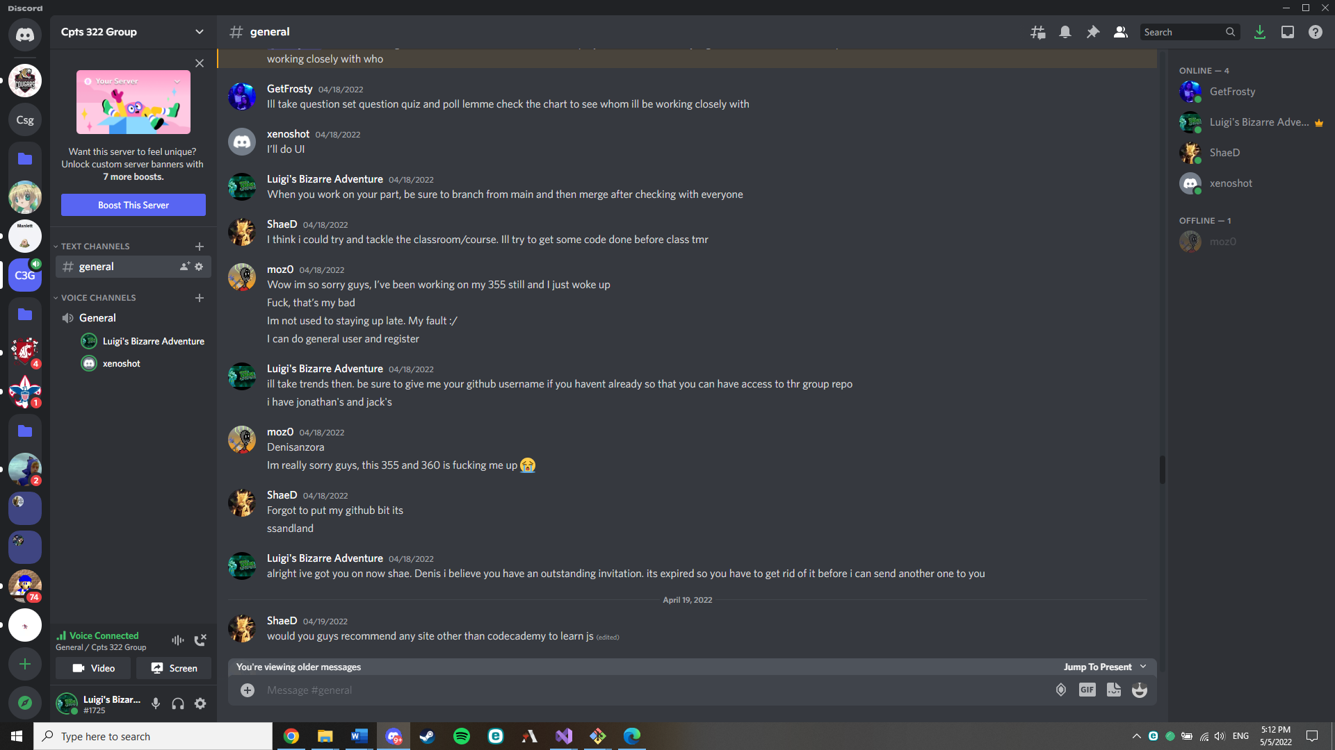

This is an example where the person in question who was to help the group with Javascript missed one of our group meetings set to discuss workloads.

The inconsistence of this person led to many delays and lots of confusion on work. As I’m writing this the due date of milestone 8, he is no where to be found helping this project and only has contributed a small chunk to it.

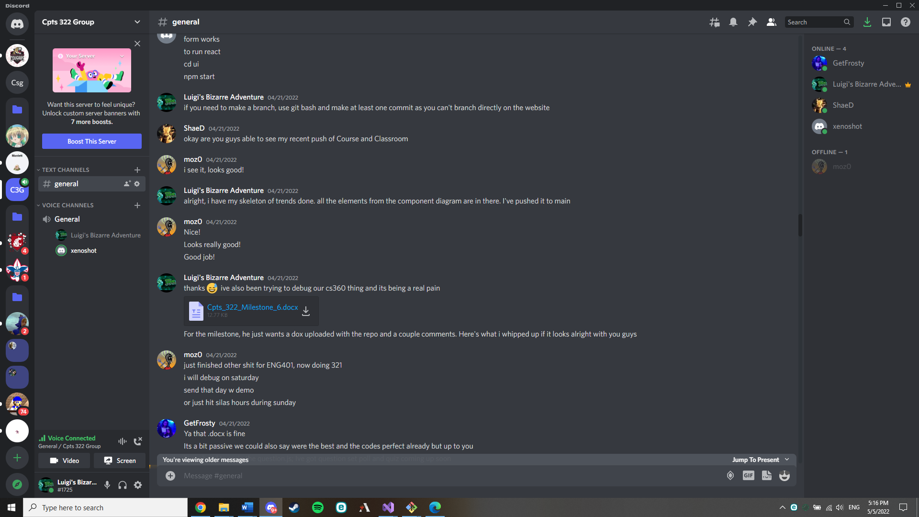

This wasn’t a project without effort involved and lots of work was put into it. ShaeD was a person who was struggling with JS and did the best he could while trying to learn an entire language. I myself tried hard to understand the unique nature of a typeless language. This is an instance where while we think it was good to go, we weren’t really sure and instead of explaining to us how our parts were good, we just got simple responses as seen. Later in testing, I found that the skeleton was in fact not good to go and wouldn’t render properly in the html page.

1. Fast forward again to recently. I’ve completed the test functions I wanted to use for testing my component, but I’m not able to test is since the person working on the UI needs to integrate the tests.

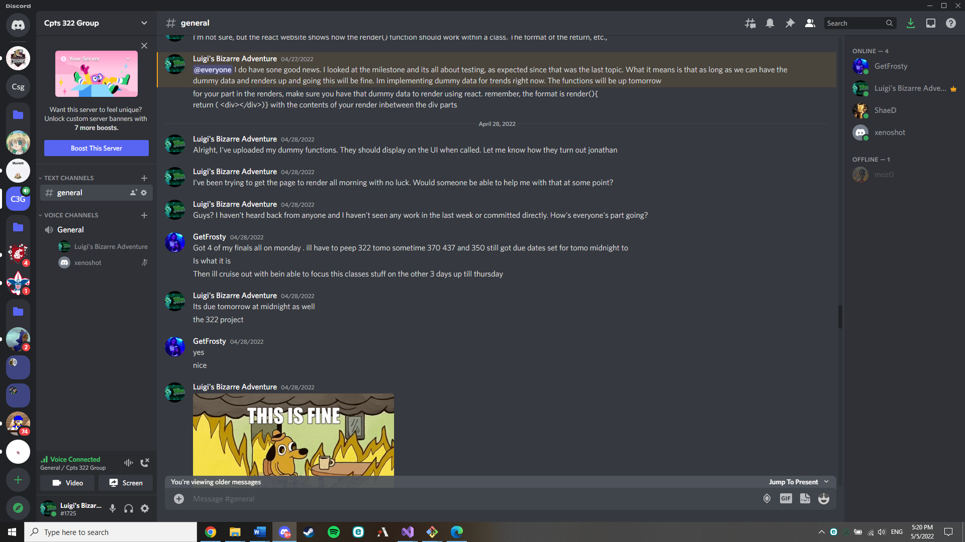

I was only able to test yesterday as it turned out there was a bug on the UI where when we pulled from github, we weren’t able to test it since the script used for running the website was missing from the repository, but not the UI creator.

1. Now we arrive in present day, I am sitting here working on my part as best as I can as well as the UI person in the discord call, but it’s too late. The damage is done and the project will not be complete. The person who said they would help with Javascript isn’t in the call, it’s just myself and one other person.

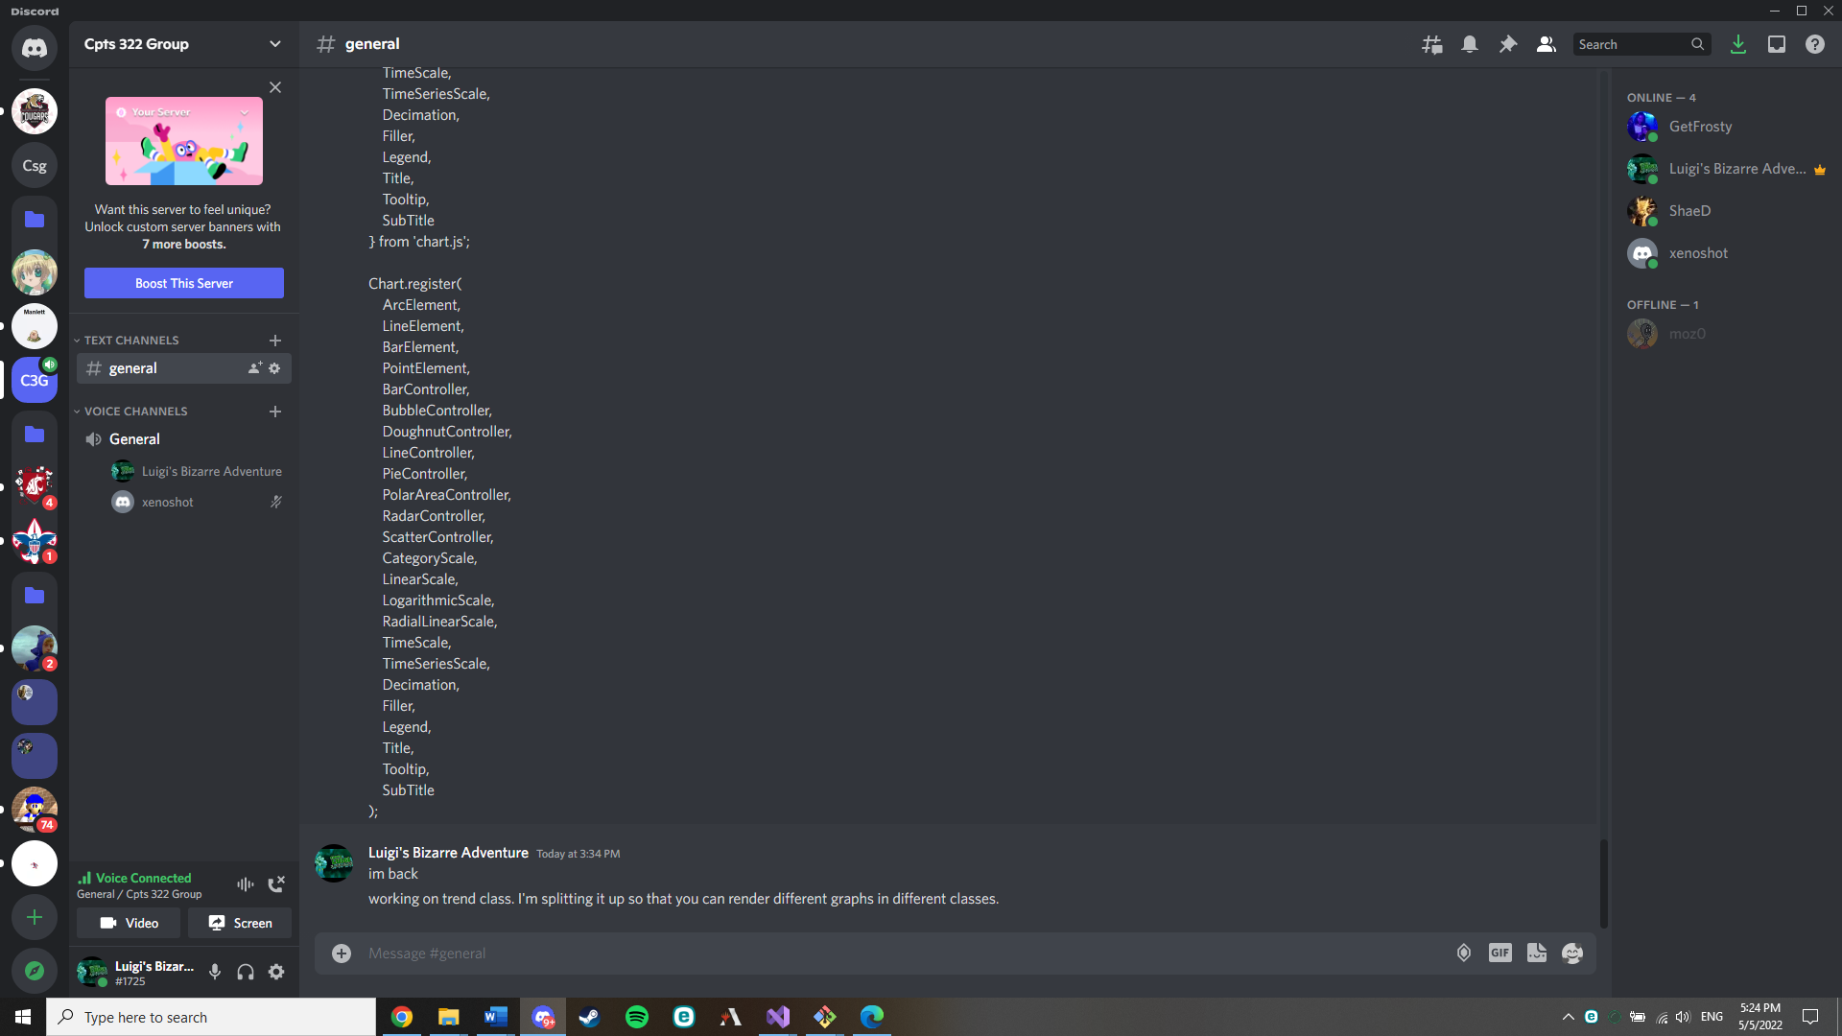

This is just a screenshot of our group chatroom only containing myself and the UI person.

**Conclusion**

From this point I would like to refer to how I think people have performed in this group and for reference in discord screenshots

Luigi’s Bizarre Adventure = myself, John Sbur

Moz0 = Denis Anzora

Xenoshot = Jonathan Banos

GetFrosty = John Kendall

ShaeD = Shae

I don’t think that moz0 should get much credit for this after proving to be very flaky and not committing to helping the group learn a new language for a project unlike anything the rest of us have done. John Kendall was also proven to be quite flaky and there are multiple examples of him waiting until the last day to complete his part not just for this project, but also milestones previously. The screenshots display him waiting for milestone 7 until Friday night, but also leaving our meeting for discussing the project after seeing that no one was there, even though we told him where we were meeting and never saw him come there. After explaining where it was, he still didn’t come and ended up just heading home. ShaeD was at first a little flaky in milestones, but after a thirdway through the semester, he really started to pull through and worked hard on his part in the project. He really couldn’t get more done because he didn’t know what to do or if it worked because, well, Denis wasn’t there to help him with his part. Jonathan and myself have really been trying to get this project done so I would hope to get some credits for this project. We are in reality the only two working on it and have been the only two working on it for the last week and a half aside from Shae who can’t progress his part anymore.

This concludes my peer evaluation and explanation about how this project went so I do hope you consider this in the final grade for each of us.